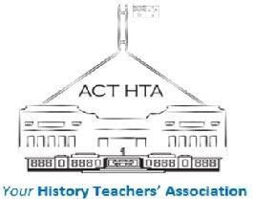  ABN 64 308 951  GST Free | ACT and District History Teachers’ Association  (ACTHTA)  Membership 2022  (Tax Invoice)

Member Details

Your Name

School or Institution

Preferred Email

Membership Options:

All memberships include free or heavily discounted Professional Learning Opportunities.

(Fees unchanged for 2022!)

(please tick whichever applies)

 | Individual Membership $50 |  |  | Cultural Institution $120  (maximum 3 attendees at any event)
School Membership $100
(maximum 3 attendees at any event)

 | Pre-Service Teacher Free |  |  | Please ADD (if desired)  HTANSW Journals for 2022 $50  (4 per year)

Payment Methods:

- By Direct Debit – BSB 062904 Account 0090 3201 (ACTHTA)
or
- In person, via debit or credit card.

Please return this form to Rebecca.gill@ed.act.edu.au or nick.ewbank@radford.act.edu.au.

